MiniProj4
Text Mining and Network Analysis of Digital
Libraries in R

Eric Nguyen
FinancialMood Analytical Services, Inc. Montreal, Quebec, Canada

4.1 Introduction

With the availability of open and structured data, digital libraries become an important source of data in recent data mining techniques. The inherent structure of digital libraries comes with information about date, authorship, involved institutions, geographic context, and large volumes of text.

As an illustration of digital libraries analysis, we will focus on a space of scientific publications related to some science discipline and extract patterns and text-related information from the dataset. Text mining techniques offer a reliable and efficient way to quantify many aspects of digital libraries, as well as methods to cluster and regroup digital content in relation to topical content. This chapter will discuss about text preparation techniques in R, the use of the latent Dirichlet allocation (LDA) to classify content, and the analysis of text features, like co- occurrence matrices. Simple similarity measures between authors and between papers will be used to illustrate cluster cohesion within the dataset.

On top of text analysis, scientific collaboration is often mirrored in terms of citations and references, which will allow us to build a network of interactions. Various centrality measures of impact and influence of scientific collaborators and participants are then derived from the network. This chapter will make extensive use of the tm, sna, and the lda R packages. Theoretical aspects of the various algorithms will also be discussed, as well as R code snippets and relevant charts.

The following outline describes the different steps of our analysis:

1. Dataset preparation:
Using the tm R package, we parse the text content of our dataset. This involves using various functions to get rid of undesirable characters and terms such as punctuation characters, whitespaces, and stop words.

95

2. Exploring the document-term matrix:
The document-term matrix is a useful object, which describes the relationships between documents and terms. The tm R package provides methods to deal with term sparsity and to find associations between terms. A discussion about the term frequency-inverse document frequency measure and how it can be used in R is also part of this section.
3. Topical analysis and content clustering using the LDA:
The LDA is a model where documents are viewed as a mixture of topics. One can use the lda R package to learn about a topic representation from the documents of a dataset. This section covers how to run the learning algorithm, validate the model using log-likelihood values, describe the different topics resulting from the LDA model, and how to visually paint the topic representation of each document.
4. Document cohesion using a similarity measure:
From the LDA model, each document has a mixture of topics associated with it. These attributes can be used to derive a concept of similarity, where similar documents have similar topic distribution. In this section, we show how one can compute a simple cosine similarity measure on the documents of the dataset, and use a heatmap to illustrate the different document clusters.
5. Social Network Analysis of authors:
As a final analysis, we build a network of authors based on coauthorship
interactions between the different participants. The igraph R package will allow us
to construct a graph representing our network, and, using the sna package, we apply a measure of centrality to the nodes of our graph to describe which authors are more important (in terms of collaboration). This analysis can be extended to other type of networks.

4.2 Dataset Preparation

ArXiv.org is an archive of electronic preprints of scientific publications provided by Cornell University. The available topics include mathematics, physics, computer science, statistics, quantitative finance, and biology. It was launched in 1991 and includes more than half a million articles.

The first dataset to be explored is the set of all abstracts of papers submitted during the year
2011 in the mathematics subject. The data are included in the 2011-papers.Rdata file and was generated externally from the arXiv.org website, using the curl command line tool and a few perl scripts.

A corpus is the set of all documents and can be thought of as a database of text files. To load the abstracts into a corpus in R, get to the directory and enter:

> setwd(“Data”)
> library(tm)
> s <- Corpus(DirSource(“abstracts”))

To start our text analysis of all the abstracts, we want to remove undesirable characters, such as whitespaces, punctuations, and treat all words in their lowercase form. The tm
library includes a few text processing functions which can be applied to our corpus
(Feinerer, 2011).

> s <- tm_map(s, tolower)
> s <- tm_map(s, removePunctuation)
> s <- tm_map(s, removeWords, stopwords(“english”))
> s <- tm_map(s, stripWhitespace)
All functions tolower, removePunctuation, removeWords, and stripWhitespace are applied to each document in our corpus. We use the removeWords function to remove various stop words, which we consider noisy in our data. The list provided by the tm library includes words such as the, is, on, at. The last function stripWhitespace will collapse repeated whitespaces resulting from the previous text manipulations.

> summary(s)
A corpus with 1870 text documents

The metadata consists of 2 tag-value pairs and a data frame
Available tags are:
create_date creator
Available variables in the data frame are: MetaID

> s[[1]]
noncommutative solitons quasideterminants masashi hamanaka discuss extension soliton theory integrable systems noncommutative spaces focusing integrable aspects noncommutative antiselfdual yangmills equations wide class exact solutions solving riemannhilbert
[.. .]
The tm package contains many more transformation functions, such as removeCitation, removeMultipart, removeNumbers, and more. The reader is redirected to the tm user manual for more information about these other functions.

4.3 Manipulating the Document-Term Matrix

4.3.1 The Document-Term Matrix

Now that we have collected all our abstracts, we can build the document-term matrix associated with the collection of abstracts. The document-term matrix is simply a matrix describing the frequencies of all terms occurring in the collection of text documents.

> dtm <- DocumentTermMatrix(s)
Note that the tm package also has the TermDocumentMatrix class, which allows the user to work in a transposed way where terms are represented as rows, as opposed to columns as in the case of DocumentTermMatrix. In the present example, we will use the

DocumentTermMatrix class. All functions related to the DocumentTermMatrix class can also be applied to the TermDocumentMatrix class.

Using the DocumentTermMatrix, each row corresponds to a document in the corpus and each column corresponds to a term. For example, one can get a partial view of the matrix with:

> inspect(dtm[1:5, 1:5])
A document-term matrix (5 documents, 5 terms)

Non-/sparse entries: 0/25
Sparsity : 100% Maximal term length : 10
Weighting : term frequency (tf)

Terms
Docs | 00879873 | 012 | 0134 | 013indexed | 01d
1101.0005.txt | 0 | 0 | 0 | 0 | 0
1101.0006.txt | 0 | 0 | 0 | 0 | 0
1101.0012.txt | 0 | 0 | 0 | 0 | 0
1101.0013.txt | 0 | 0 | 0 | 0 | 0
1101.0015.txt | 0 | 0 | 0 | 0 | 0
The entries of the matrix are simply the frequencies associated with the terms in the
corresponding document.

> dtm
A document-term matrix (1870 documents, 20176 terms)

Non-/sparse entries: 80702/37648418
Sparsity : 100% Maximal term length : 327
Weighting : term frequency (tf)
When printing out the dtm object, a few statistics are displayed. First, the number of sparse and nonsparse entries is displayed. A value of 0 in the matrix is considered a sparse entry and a nonzero value is a nonsparse entry. In our case, we have 1870 documents and 20,176 terms, yielding 37,729,120 entries in total. Among these entries, 80,702 entries are nonzero values, and the rest of the matrix, the other 37,648,148 entries, is zero. Sparsity is the proportion of sparse entries in the entire matrix. The maximal term length is the number of terms in the longest document in our corpus. The default weighting method when instantiating a DocumentTermMatrix is the term-frequency weighting. A detailed discussion on this parameter is given below.

There are a few options one can use with the DocumentTermMatrix. The first setting is the lower and upper bounds of global term frequencies to be considered. Terms appearing in the collection of documents less often than the specified lower bound will be ignored, and similarly with terms appearing more frequently than the upper bound.

> dtm.2 <- DocumentTermMatrix(s, control¼list(bounds ¼ list(global ¼ c(2,Inf))))
> dtm.2
A document-term matrix (1870 documents, 6404 terms)

Non-/sparse entries: 66930/11908550
Sparsity : 99% Maximal term length : 46
Weighting : term frequency (tf)
In the example above, terms which appears only once in the whole corpus will be ignored when building the document-term matrix. Note that the number of terms in our matrix has dropped because we specified frequency bounds.

For a conventional set of text documents, the size of DocumentTermMatrix objects tends to grow at an undesirable rate. A high proportion of the entries are sparse, hence one can significantly reduce the size of the matrix by removing sparse terms without significantly affecting the overall analysis.

> removeSparseTerms(dtm, 0.99)
A document-term matrix (1870 documents, 803 terms)

Non-/sparse entries: 40560/1461050
Sparsity : 97% Maximal term length : 16
Weighting : term frequency (tf)
The removeSparseTerms function returns another DocumentTermMatrix, duplicated from the one supplied in the argument, from which sparse terms have been removed. In our example, terms which are 80% sparse were removed from the DocumentTermMatrix object. In other words, terms which do not appear in at least 80% of all documents are removed from the original DocumentTermMatrix object.

Another interesting feature of the DocumentTermMatrix class in R is the availability of using an arbitrary frequency measure other than the standard frequency count. The following section covers that particular aspect about the DocumentTermMatrix class.

4.3.2 Term Frequency-Inverse Document Frequency

Given a corpus D, a term ti and a document dj 2 D, we denote the number of occurrences of ti in
dj by tfij. This is referred as the term frequency.

The inverse document frequency for a term ti is defined as

idf i ¼ log j
D j
jfd : ti 2 dgj

where ∣ D ∣ is the number of documents in our corpus, and ∣ {d : ti 2 d} ∣ is the number of documents in which the term appears. If the term ti appears in every document of the corpus, idfi is equal to 0. The fewer documents the term ti appears in, the higher the idfi value.

The measure called term frequency-inverse document frequency (tf-idf) is defined as tfij*idfi
(Salton and McGill, 1986). It is a measure of importance of a term ti in a given document dj. It is a

term frequency measure which gives a larger weight to terms which are less common in the corpus. The importance of very frequent terms will then be lowered, which could be a desirable feature.

There are many variants of the tf-idf measure, and some variants will give better results depending on the given dataset (Salton and Buckley, 1988). For example, a variant of the tf-idf measure where the term frequency factor scales sub-linearly, like when tf 0 i ¼ log(1 þ tfi), will deflate the weight given to frequent terms. This could be useful when term frequencies follow a power law with respect to the rank. The tf-idf function provided with the tm package is the standard one defined earlier.

To construct a document-term matrix such that the entries are tf-idf values, one would use:

> dtm.tfidf <- DocumentTermMatrix(s, control¼list(weighting¼weightTfIdf))
> dtm.tfidf
A document-term matrix (1870 documents, 20176 terms)

Non-/sparse entries: 80702/37648418
Sparsity : 100% Maximal term length : 327
Weighting : term frequency - inverse document frequency
(normalized) (tf-idf)
> inspect(removeSparseTerms(dtm.tfidf, 0.9)[1:5, 1:5]) A document-term matrix (5 documents, 5 terms)

Non-/sparse entries: 3/22
Sparsity : 88% Maximal term length : 9
Weighting : term frequency - inverse document frequency
(normalized) (tf-idf) Terms
Docs | consider | finite function functions | model
1101.0005.txt | 0 | 0 0.00000000 0.00000000 | 0
1101.0006.txt | 0 | 0 0.07768253 0.00000000 | 0
1101.0012.txt | 0 | 0 0.11652380 0.00000000 | 0
1101.0013.txt | 0 | 0 0.00000000 0.00000000 | 0
1101.0015.txt | 0 | 0 0.00000000 0.06001211 | 0

Note that by using tf-idf as a frequency measure, we are now dealing with real values instead of integral entries.

The weighting parameter of the control option of the DocumentTermMatrix constructor adds flexibility by allowing arbitrary term frequency measures, as long as the provided function can parse a corpus object.

4.3.3 Exploring the Document-Term Matrix

Once the document-term matrix has been decided on, one can list terms with a frequency higher than a threshold by typing:

> findFreqTerms(dtm, 400)
[1] “finite” “paper” “prove” “results” “space” “theory”
Here, the words with frequency higher than 400, across the whole collection of documents, are shown.

Given a term, one can also find out which words are highly correlated with that term by using the findAssocs function. This function also requires a correlation limit as an argument.

> findAssocs(dtm.2, “graph”, 0.3)[1:3]
graphs edge vertices
0.49 0.39 0.37
> findAssocs(dtm.2, “edge”, 0.3)
vertex adjacent graph graphs chordal cut
0.41 0.39 0.39 0.33 0.31 0.31 located maintains picks walker
0.31 0.31 0.31 0.31
In this case, the terms “graphs,” “edge,” and “vertices” are correlated with the term “graphs.” By lowering the correlation limit, more terms appear from the output of findAssocs.

4.4 Clustering Content by Topics Using the LDA

4.4.1 The Latent Dirichlet Allocation

The LDA is a technique developed by David Blei, Andrew Ng, and Michael Jordan and exposed in Blei et al. (2003). The LDA is a generative model, but in text mining, it introduces a way to attach topical content to text documents. Each document is viewed as a mix of multiple distinct topics. An advantage of the LDA technique is that one does not have to know in advance what the topics will look like. By tuning the LDA parameters to fit different dataset shapes, one can explore topic formation and resulting document clusters.

The mathematics behind the LDA is beyond the scope of this work, but one should be aware of the following aspects of the algorithm. The number of topics K is fixed and specified in advanced. The corpus contains documents di ¼ wi, 1 , :::, wi, ni of length ni. Each word wi,j comes from a vocabulary which consists of V different terms.

The term distribution for each topic is modeled by

bi Dirichletð Þ

where Dirichlet( ) denotes the Dirichlet distribution for parameter . The proportion of topic distribution for each document is distributed as
oi DirichletðaÞ

Each word wi,j is associated to a topic zi,j which follows

zi, j Multinomialðoi Þ

where Multinomial(oi) denotes the multinomial distribution with one trial (Grun and
Hornik, 2011).

In this setup, the LDA is a “bag of words” model, where the order in which the words appear does not affect the grammar.

4.4.2 Learning the Various Distributions for LDA

Given a set of documents, one can use the LDA framework to learn the different distributions describing a model about the topic representation of the documents in the corpus. Each
word is then associated with a topic, and each topic has a term distribution that helps make sense of it. One way to turn this into a learning algorithm is by using the collapsed Gibbs sampling method.

Before the first iteration, the algorithm starts by assigning a random topic to each word in each document. Then, at each iteration, the algorithm goes through each word wi,j in document di. For each topic Tk, it computes p(Tk ∣ di), the observed portion of words assigned to topic Tk in document di, and p(wi,j ∣ Tk), the portion of assignment to topic Tk that comes from the word wi,j. The algorithm then resamples a new topic T’i,j for wi,j with probability p(Tk ∣ di)*p(wi,j ∣ Tk) before it jumps to the next word.

An iteration is completed when all words in all documents are revisited. After a large number of iterations, the model tends to converge to a steady state of topic assignment. We will use the LDA model with R to model topics for our corpus from arXiv.org.

For the following section of the chapter, the lda package is required.

> library(lda)
The R implementation of LDA requires the input to be suitably formatted. The lexicalize
function will help us address this issue.

[.. .]
> lex <- lexicalize(s)
> head(lex$vocab)
[1] “noncommutative” “solitons” “quasideterminants” [4] “masashi” “hamanaka” “discuss”
> lex$documents[[1]]
 | [,1] | [,2] | [,3] | [,4] | [,5] | [,6] | [,7] | [,8] | [,9]
[1,] | 0 | 1 | 2 | 3 | 4 | 5 | 6 | 7 | 8
[2,] | 1 | 1 | 1 | 1 | 1 | 1 | 1 | 1 | 1
[.. .]

Here, the variable s is the clean version of our corpus, produced earlier in the current work. The list lex$vocab is the vocabulary associated with the corpus. The first row of lex
$documents[[1]] is the list of term indices, from lex$vocab, and the second row of lex
$documents[[1]] is the term frequency of each term of the first document of our corpus. We are now ready to run the LDA on the resulting lex object:
> res <- lda.collapsed.gibbs.sampler(lex$documents, 10, lex$vocab, 100, 0.1, 0.1, compute.
log.likelihood¼T)
In our example, the lda.collapsed.gibbs.sampler function takes the following arguments:

• an object resulting from lexicalize, in our case the lex$documents object
• the number of topics in the model
• the vocabulary associated with the corpus, lex$vocab
• a number of iterations for the Gibbs sampling
• the a parameter describing the term distribution for each topic
• the parameter describing the topic distribution for each document
• a flag indicating whether the log-likelihood should be computed and returned. The log- likelihood is useful when one wants to determine convergence of the LDA process. Details about this return value are discussed below.

The resulting object, res in our case, contains a few important attributes:

• res$assignments: a list of vectors representing the topic association of each term in each document of our corpus. Each entry of res$assignments corresponds to
a document.
• res$document_sums: a matrix representing the number of times the terms in each document were associated with each of the topics. Rows represent topics and columns are documents.
• res$log.likelihoods: a matrix with two rows. The first row lists the full log-
likelihood values for each iteration, and the second row lists the log-likelihood values of the observations conditioned on the arguments for each iteration.

> res$assignments[[1]]

[1] 5 7 5 5 7 5 5 7 5 7 7 5 5 7 5 5 5 5 5 7 7 7 7 7 7 7 5 5 [.. .] [39] 5 5 5 5 5 7 5 5 5 5 5 7 5 5 7 7 5 5 7 7 7
> res$document_sums[,1:10]
 | [,1] | [,2] | [,3] | [,4] | [,5] | [,6] | [,7] | [,8] | [,9] | [,10]
[1,] | 0 | 0 | 0 | 0 | 0 | 6 | 0 | 0 | 0 | 0
[2,] | 0 | 8 | 0 | 0 | 0 | 1 | 0 | 0 | 0 | 0
[3,] | 0 | 8 | 0 | 4 | 0 | 0 | 0 | 0 | 0 | 27
[4,] | 0 | 0 | 0 | 0 | 39 | 0 | 0 | 10 | 0 | 0
[5,] | 0 | 0 | 8 | 0 | 0 | 61 | 0 | 0 | 0 | 1
[6,] | 36 | 0 | 0 | 0 | 11 | 2 | 0 | 0 | 3 | 0

[7,] | 0 | 5 | 0 | 0 | 0 | 20 | 59 | 2 | 1 | 0
[8,] | 23 | 21 | 43 | 25 | 3 | 0 | 0 | 3 | 17 | 0
[9,] | 0 | 0 | 1 | 0 | 0 | 0 | 0 | 0 | 0 | 0
[10,] | 0 | 0 | 0 | 0 | 0 | 10 | 0 | 0 | 20 | 32
> res$log.likelihoods
[.. .]

[,98] [,99] [,100] [1,] -1015611.5 -1015942.5 -1015845.9 [2,] -902856.1 -903184.8 -903122.7
Note that the topic assignment values from res$assignments range from 0 to 9, whereas the row indices, which correspond to topics, of res$document_sums go from 1 to 10. Note also that because the LDA process is not deterministic, the output might differ from the
current example.

4.4.3 Using the Log-Likelihood for Model Validation

Given a statistical model and parameter values, one can ask what the probability of the observed outcomes is. Alternatively, given a set of outcomes, one can ask how likely the set of parameters is. This probability is what we mean by likelihood. It is a measure of the parameters being appropriate given a set of observations.

In our case, the set of observations is the set of existing documents and the different topic associations for each word occurring in each document. The parameters are the a and parameters, the multinomial and dirichlet distributions, and K, the number of topics. By itself, the log-likelihood value does not have a significant meaning. But, different models can be compared based on their log-likelihood values. In other words, given the same set of observations, two models having different parameters can be compared based on their likelihood: a model with greater likelihood is considered more appropriate given the set of observations.

In many cases, it is more convenient to work with the natural logarithm of the likelihood value, known as the log-likelihood. Because the log function is monotone increasing, the maximum of both the log-likelihood and the likelihood coincide at the same point.

By specifying the compute.log.likelihood flag, one can plot the returned log-likelihood values to verify convergence (Figure 4.1). A simple way to do so could be:

> par(mfrow¼c(2,1), pch¼20)
> plot(1:100, res$log.likelihoods[1,])
> plot(1:100, res$log.likelihoods[2,])
From the plots, we can observe that the log-likelihood convergence slowly. After 50 iterations, the additional iterations did not seem to improve the model so much. The choice of 100 iterations in our example was a first blind attempt at generating a valid model. By plotting the log-likelihood values, one can determine whether modifying the number of iterations can significantly impact the log-likelihood of the model, hence improve the final model.

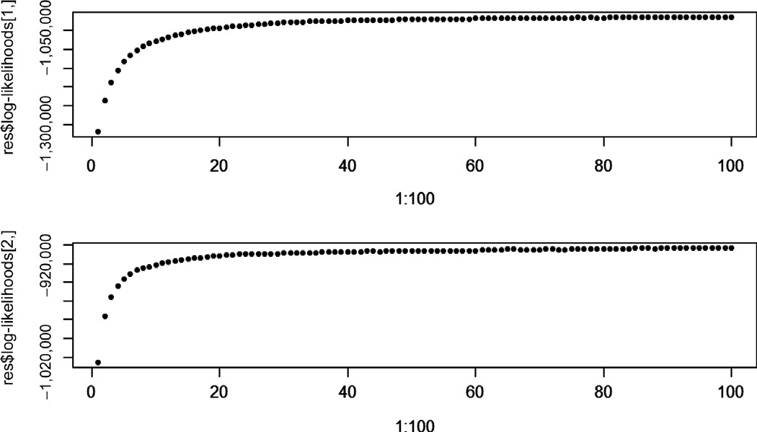
Figure 4.1
Log-likehood values from iterations.

4.4.4 Topics Representation

In our example, document 1 would have 36 terms associated with topic 6, and 23 terms with topic 8. Unfortunately, topics are not explicitly defined in our model. One way to describe each topic is to sort out associated terms with high frequency and scores. The lda package provides the top.topic.words function which outputs high-usage terms for each topic.

> top.topic.words(res$topics, 5, by.score¼T)
[,1] [,2] [,3] [,4] [,5] [1,] “curvature” “convex” “random” “algebra” “space”
[2,] “surfaces” “functions” “process” “algebras” “operators” [3,] “conjecture” “sets” “distribution” “category” “spaces” [4,] “surface” “set” “processes” “ring” “operator” [5,] “geometry” “property” “brownian” “cohomology” “theory”
[,6] [,7] [,8] [,9] [,10]
[1,] “quantum” “graph” “equations” “channel” “systems” [2,] “polynomials” “graphs” “solutions” “capacity” “stochastic”
[3,] “functions” “set” “equation” “codes” “model”
[4,] “noncommutative” “bound” “solution” | “network” | “numerical”
[5,] “theory” “vertices” “wave” | “coding” | “system”
In our example, topic 1 relates to mathematical physics. The LDA algorithm, in our current
case, associated the majority of terms of document 1 to topic 6. In fact, the title of document 1 in arXiv.org is “Noncommutative Solitons and Quasideterminants” and is categorized in the mathematical physics subject.

The lda package also includes the top.topic.documents function which returns the top documents for each topic. The output is also in matrix format, just like the top.topic. words function.

4.4.5 Plotting the Topics Associations

Using a combination of the reshape, ggplot2, and RColorBrewer packages, one can create a stacked bar chart illustrating the weight of each topic for all documents in our corpus.

The ggplot2 package is an advanced plotting system and is an implementation of the grammar of graphics in R. It gives the possibility to draw complex charts by exposing a way to manipulate plot aesthetic features to express multidimensional attributes of the data.

The RColorBrewer is an R package that provides predefined color palettes and ways to generate arbitrary color mappings shaded according to a variable.

The first step is the use of the res$document_sums matrix and reshape it into a data.frame object. The melt function allows the user to use a high-dimensional array and transform it into a dataframe. The coordinates of each matrix entry become columns in the dataframe, and each entry in the matrix gets turned into a row in the resulting dataframe.

> library(reshape)
[,1] [,2] [,3] [,4] [,5] [,6] [1,] 0 0 0 0 0 6 [2,] 0 8 0 0 0 1 [3,] 0 8 0 4 0 0 [4,] 0 0 0 0 39 0 [5,] 0 0 8 0 0 61 [6,] 36 0 0 0 11 2 [7,] 0 5 0 0 0 20 [8,] 23 21 43 25 3 0 [9,] 0 0 1 0 0 0 [10,] 0 0 0 0 0 10
> d <- melt(res$document_sums)
> colnames(d) <- c(“topic”, “document”, “value”)
> head(d)
topic document value
1 | 1 | 1 | 0
2 | 2 | 1 | 0
3 | 3 | 1 | 0
4 | 4 | 1 | 0
5 | 5 | 1 | 0
6 | 6 | 1 | 36
Notice how the third column of the dataframe contains the entries of the matrix. Row and
column indices become values in the resulting dataframe.

The following example will give us the desired plot, for the 50 first documents of our corpus
(Figure 4.2).

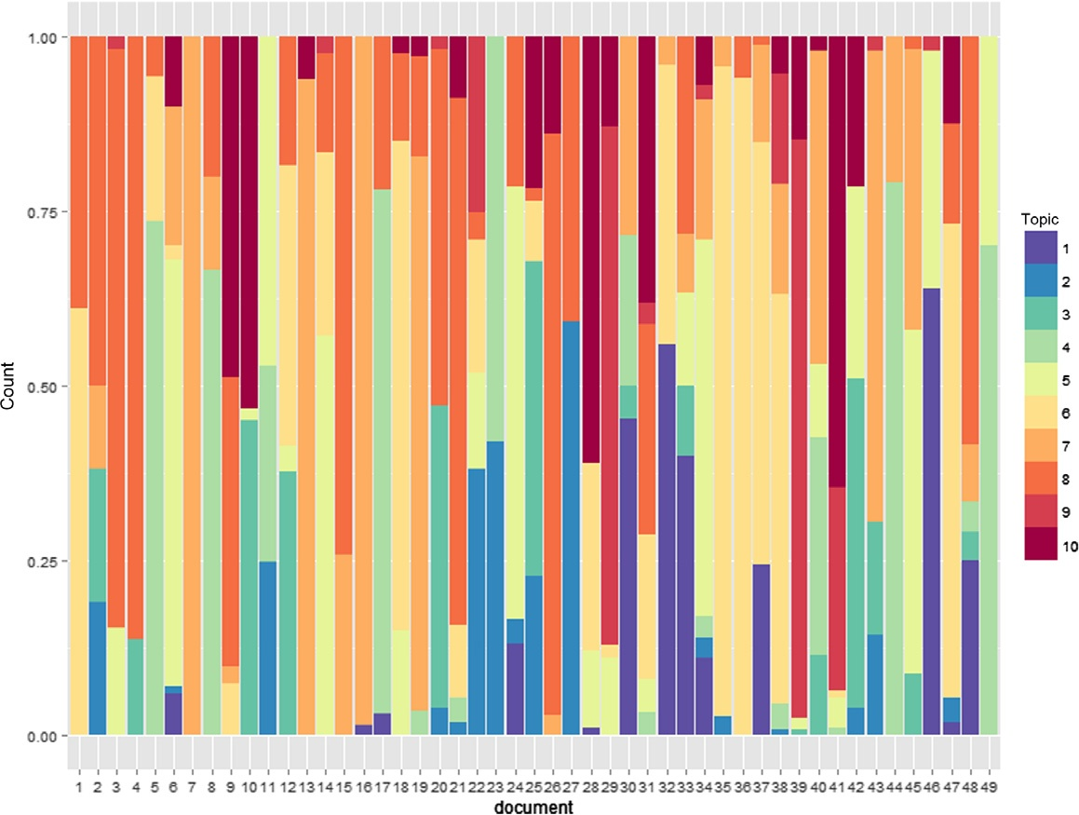
Figure 4.2
Distribution of topics in documents.

> library(ggplot2)
> library(RColorBrewer)
> d2 <- subset(d, d$document < 50)
> d2$topic <- as.factor(d2$topic)
> d2$document <- as.factor(d2$document)
> ggplot(d2, aes(x ¼ document)) þ geom_bar(aes(weight¼value, fill ¼ topic), position ¼
’fill’) þ scale_fill_manual(values ¼ rev(brewer.pal(10, “Spectral”)))
The stacked bar chart gives a more illustrative perspective of how the documents are distributed in the space of topics.

The lda package also includes two other methods to fit models: the mixed-membership stochastic blockmodel and the supervised LDA. They are called, respectively, by slda.em and mmsb.collapsed.gibbs.sampler. These LDA-type models have different features and are not discussed in the current chapter.

4.5 Using Similarity Between Documents to Explore Document Cohesion

4.5.1 Computing Similarities Between Documents

Let us determine how documents relate to each other in our corpus. Let t1 and t2 be two vectors,

respectively, representing the topic associations of documents d1 and d2, where t(i)
1
2
and t(i)
are,

respectively, the number of terms in d1 and d2, which are associated with topic i. One can then use the cosine similarity to derive a measure of document similarity:

P ðiÞ

ðiÞ

Here, k tjk denotes the norm of vector tj.
i t 1 t2
kt1 k kt2 k

In the current example, we will use the rows of the matrix res$document_sums as the list of features. Hence, two documents are similar if they share a similar topic distribution. The following lines will compute and output the similarity matrix for the documents.

> mat <- t(as.matrix(res$document_sums)) %*% as.matrix(res$document_sums)
> d <- diag(mat)
> sim <- t(t(mat/sqrt(d))/sqrt(d))
> sim[1:5, 1:5]
[,1] | [,2] | [,3] | [,4] | [,5]
[1,] 1.0000000 | 0.46389797 | 0.52916839 | 0.53162745 | 0.26788474
[2,] 0.4638980 | 1.00000000 | 0.84688328 | 0.90267821 | 0.06361709
[3,] 0.5291684 | 0.84688328 | 1.00000000 | 0.97052892 | 0.07256801
[4,] 0.5316274 | 0.90267821 | 0.97052892 | 1.00000000 | 0.07290523
[5,] 0.2678847 | 0.06361709 | 0.07256801 | 0.07290523 | 1.00000000
The resulting matrix is a symmetric matrix where the entry in row i and column j represents the
cosine similarity measure between documents di and dj. The larger the entries, the more similar the publications are in terms of topic associations. An entry of 1 indicates identical publications in terms of topic associations.

In our example, documents 3 and 5 are completely dissimilar and documents 2 and 3 are somewhat similar. As a matter of fact, document 3 relates to the analysis of partial differential equations and document 5 discusses quantum algebra. Document 2 in our corpus is a scientific paper discussing the analysis of partial differential equations as well.

Alternatively, one can use the res$document_sums matrix to compute distances between the documents, instead of using cosine similarity measure. The dist function in R allows one to do so.

> as.matrix(dist(t(res$document_sums)))[1:5, 1:5]
1 | 2 | 3 | 4 | 5
1 0.00000 | 38.11824 | 41.96427 | 36.27671 | 50.45790
2 38.11824 | 0.00000 | 26.49528 | 11.00000 | 46.03260
3 41.96427 | 26.49528 | 0.00000 | 20.12461 | 57.50652
4 36.27671 | 11.00000 | 20.12461 | 0.00000 | 46.28175
5 50.45790 | 46.03260 | 57.50652 | 46.28175 | 0.00000

Again, the distance between documents 2 and 3 is relatively small compared to other distance values, which reflects the fact that they are somewhat similar.

The dist function accepts many arguments, but the most important one is the method used for computing distances. This makes it easier to adjust the distance calculation method to the underlying dataset and objectives. The provided options are the euclidean, which happens to be the default one, the maximum, the manhattan, the canberra, the binary, and the minkowski distance methods. The different distance methods are detailed in the dist function help page.

4.5.2 Using a Heatmap to Illustrate Clusters of Documents

Now that the similarity matrix has been constructed, where similarity in our case is based on volume of topic associations by document, we can chart the different similarities on a heatmap and visualize which groups of documents are more likely clustered together. The simplest way to do so is to use the heatmap function (Figure 4.3).

> heatmap(sim[1:100,1:100])
> heatmap(sim[1:20, 1:20])
A yellow square indicates strong similarity, whereas a red square indicates distant documents. The second heatmap shows a subset of the same values for better readability. The reordering of the rows and columns are illustrated with dendrograms to the left and on the top of the chart. The default clustering method for the heatmap function is the hierarchical clustering, which is implemented in the hclust function.

The first step of hierarchical clustering assigns each document to its own cluster. Then, at each iteration, the two most similar clusters are joined together in a single cluster. Distances between clusters are then recomputed, and further iterations of cluster joins
are executed. The algorithm ends when only one cluster is left (Feldman and Sanger, 2006). The dendrograms shown on the charts represent each step of the hierarchical clustering algorithm.

In this case, for the second heatmap, we can see that documents 20 and 19 are similar to each other and so are documents 5, 8, 11, and 17.

The heatmap function has many other arguments, such as color choices, arbitrary distance, and clustering functions and more. The help page for the heatmap function is a good reference for more details about the different features.

4.6 Social Network Analysis of Authors

4.6.1 Constructing the Network as a Graph

In the current corpus, the names of authors have been extracted and stored separately. To load the list of authors per publication, write

> load(“s.authors.RData”)

Figure 4.3
Heatmap of similarities between documents. A) The left heatmap represents the similarity matrix from the first 100 documents. B) The heatmap on the right depicts the same idea for the first 20 documents of our corpus.

which will load a s.authors object into your R environment.

> head(s.authors, 4)
$‘1101.0012.txt’
[1] “Dirk Hundertmark” “Shuanglin Shao”

$‘1101.0013.txt’
[1] “Jinggang Tan” “Jingang Xiong”

$‘1101.0015.txt’
[1] “Michael Gekhtman” “Michael Shapiro” “Alek Vainshtein”

$‘1101.0017.txt’
[1] “Tran Vu Khanh” “Stefano Pinton” “Giuseppe Zampieri”
The following is an attempt at a simple analysis of the network of authors from our corpus. We construct a graph where the nodes consist of authors, and an edge represents a collaboration event between authors. In our case, collaborations between authors will be defined by a
joint paper.

We first remove the papers which were written by only one author.

> getJointPapers <- function(s) { if (length(s) > 1) s else c() }
> s.authors <- sapply(s.authors, getJointPapers)
The graph library used in this exercise is the igraph package (Csardi and Nepusz, 2006). The igraph package is used mainly for network analysis allowing fast analysis and prototyping (Figure 4.4). The typical usage is

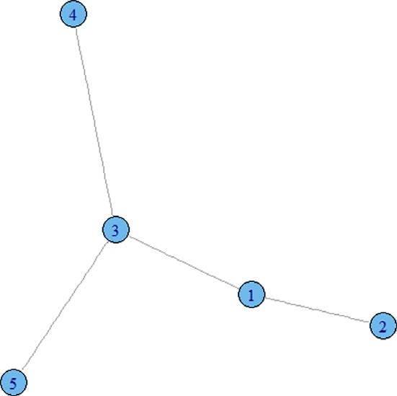
Figure 4.4
A simple graph.

> library(igraph)
> foo <- graph(c(1,2,1,3,3,4,3,5), directed¼F)
> plot(foo)
The above example creates an undirected graph with edges between vertices 1 and 2, between vertices 2 and 3, and between vertices 3 and 4. The first argument of the graph function, as used in the example, is the list of edges where all pairs are merged into a single array.

The vertices for the graph object are identified by integers, which in our case has to be associated with author names. The list of all distinct authors is constructed with:

> authors <- unique(as.vector(unlist(s.authors)))
> head(authors)
[1] “Dirk Hundertmark” “Shuanglin Shao” “Jinggang Tan” [4] “Jingang Xiong” “Michael Gekhtman” “Michael Shapiro”
We will use the indices of the authors list as the vertex identifier for the graph object, by using a helper function.

> getAuthorId <- function(n) which(authors ¼¼ n)
> getAuthorId(“Jinggang Tan”) [1] 3
Because we chose to represent our network of authors with graphs, and not hypergraphs, edges only link two authors at a time, whereas papers can have more than two coauthors. From the dataset, the third entry of the s.authors object lists three different authors:

> s.authors[[3]]
[1] “Michael Gekhtman” “Michael Shapiro” “Alek Vainshtein”
In this case, we would like to transform this into a list of three edges with author identifiers. In other words, an edge is required for each pair of authors from the list of three authors. A simple way to generate that is to use the combn function. This function generates all combinations of the elements of a vector by taking a fixed number at a time.

> combn(letters[1:4], 2)
[,1] |  | [,2] | [,3] | [,4] | [,5] | [,6]
[1,] “a” |  | “a” | “a” | “b” | “b” | “c”
[2,] “b” |  | “c” | “d” | “c” | “d” | “d”
> combn(letters[1:4], 3)
 | [,1] | [,2] | [,3] | [,4]
[1,] | “a” | “a” | “a” | “b”
[2,] | “b” | “b” | “c” | “c”
[3,] | “c” | “d” | “d” | “d”
In the above example, the first four letters of the alphabet are taken 2 and 3 at a time to form
combinations. We use the previous functions to create the list of edges for our network of authors, which we achieve by defining another helper function getEdges.

> getEdges <- function(s) { if (is.null(s) || length(s) < 2) { c() } else { unlist(lapply(combn
(s, 2), getAuthorId)) } }
> getEdges(s.authors[[3]])

[1] 5 6 5 7 6 7
> authors[c(5,6,7)]
[1] “Michael Gekhtman” “Michael Shapiro” “Alek Vainshtein”
The graph is then created with:

> g <- graph(as.vector(unlist(lapply(s.authors, getEdges))), directed¼F)
> g
IGRAPH U- - - 2639 2909 - -
The resulting g object is an undirected graph with 2639 vertices and 2909 edges. Plotting this graph isn’t practical, but there are a few things we can analyze from this network.

4.6.2 Author Importance Using Centrality Measures

Given a graph, one can speak of the centrality of a vertex which represents the importance of a vertex within the graph. This can be measured with many centrality measures, among which is the betweenness centrality measure (Leydesdorff, 2007). The betweenness of a specific vertex is equal to the number of shortest paths from all pairs of vertices in the graph that pass through that vertex. Informally, the more the shortest paths that go through a vertex, the more important that vertex is in terms of graph connectivity.

Formally, the betweenness centrality of a vertex v is
bðvÞ ¼ X suw ðvÞ
s
uw

where suw is the number of shortest paths between vertices u and w, and suw(v) is the number of shortest paths between u and w that pass through vertex v. The sum in the expression ranges over all pairs of distinct vertices u and w.

The higher the betweenness centrality value, the more central the vertex is. An implementation of the betweenness centrality computation is done in the sna R package. To apply the measure to the entire graph, we use:

> library(sna)
> b <- betweenness(as.array(get.adjacency(g)))
> head(b)
[1] 0 0 0 0 0 0
> which(b>25)
[1] 28 205 528 605 670 726 1044 1414 2034
Among the list of 2639 authors, only 9 of them have betweenness centrality measures larger than 25.

> authors[which(b>25)]
[1] “Xueliang Li” | “Vincent K. N. Lau” | “Jean-Marie Mirebeau”
[4] “Terence Tao” | “Shunqing Zhang” | “Yuliya Babenko”
[7] “Van Vu” | “Guoqing Wang” | “V. Soucek”

The above code displays the name of these 9 authors by fetching the names from the authors array. To retrieve the authors’ betweenness centrality values and use it to sort, one can use a dataframe just as in:

> top <- data.frame(name¼authors[which(b>25)], centrality¼b[which(b>25)])
> top[order(top$centrality, decreasing¼T),]
name centrality
1 Xueliang Li 55
8 Guoqing Wang 54
2 Vincent K. N. Lau 40
4 Terence Tao 34
7 Van Vu 32
3 Jean-Marie Mirebeau 30
5 Shunqing Zhang 30
6 Yuliya Babenko 30
9 V. Soucek 30
This gives us an idea of most central authors of the set of papers we are analyzing.

The betweenness centrality measure has a few variants which can affect the analysis of some networks. The length-scaled betweenness is such an example and it is given by

bðvÞ ¼ X
1
duw
uw ðvÞ
suw

where duw is the geodesic distance between vertices u and w. The geodesic distance is also known as the length of the shortest path between two vertices. The length-scaled betweenness downgrades the weight given to long paths, in situations where such paths are not likely to be useful in the analysis of the network. One can look at more variants in Brandes (2007).

To use the shortest-path betweenness centrality variants with the betweenness function, the
cmode argument is required.

> b <- betweenness(as.array(get.adjacency(g)), cmode¼“lengthscaled”)
> top <- data.frame(name¼authors[which(b>12)], centrality¼b[which(b>12)])
> top[order(top$centrality, decreasing¼T),]

 | name | centrality
1 | Xueliang Li | 27.5
3 | Guoqing Wang | 27.0
2 | Vincent K. N. Lau | 16.0
4 | V. Soucek | 13.0
We can see from this example that some authors from the first list do not appear in the list of top
authors when using shortest-path betweenness centrality.

Other variants of shortest-path betweenness centrality measures are available. They include a linearly scaled betweenness measure, a proximal source and target betweenness (where the fact that the vertex is closer to the start of the shortest path downgrades or upgrades the weight used

in the formula), and other methods. The full details of such options are available in the sna
package reference manual (Butts, 2010).

The sna package contains a wide variety of functions, including closeness measures, functions for components analysis, hierarchy analysis, and much more. Different alternative centrality measures are also implemented, which could be useful in some cases.

In this example, we analyzed the interactions between authors of our network, where interactions represent collaborative work. A similar analysis can be applied to other types of networks as well, and the sna R package provides many tools to handle this type of exercise.

4.7 Conclusion

From the content of a digital library such as arXiv.org, R has been used with a wide variety of packages to analyze the textual content of the scientific publications, the term occurrences within the different documents, the co-occurrences of terms with other terms, the clustering of papers into different arbitrary topics, and the network analysis of their authors. The LDA algorithm allowed the user to learn a topic assignment model given a set of documents and words. A few plots and charts were plotted using the ggplot2 package to visually enhance the analytical content of the different techniques used in the current chapter.

References

Blei, D.M., Ng, A.Y., Jordan, M.I., 2003. Latent Dirichlet allocation. J Mach Learn Res 3, 993–1022.
Brandes, U., 2007. On variants of shortest-path betweenness centrality and their generic computation. Soc Netw
30 (2), 136–145.
Butts, C.T., 2010. sna: tools for social network analysis. R package version 2.2-2. http://cran.r-project.org/web/
packages/sna/sna.pdf.
Csardi, G., Nepusz, T., 2006. The igrah software package for complex network research. http://igraph.sf.net. Feinerer, I., 2011. tm: text mining package. R package version 0.5-5. http://cran.r-project.org/package¼tm. Feldman, R., Sanger, J., 2006. The Text Mining Handbook: Advanced Approaches in Analyzing Unstructured Data.
Cambridge University Press, New York.
Grun, B., Hornik, K., 2011. Topicmodels: an R package for fitting topic models. http://cran.r-project.org/web/
packages/topicmodels/vignettes/topicmodels.pdf.
Leydesdorff, L., 2007. Betweenness centrality as an indicator of the interdisciplinarity of scientific journals. J. Am.
Soc. Inf. Sci.. 58 (9), 1303–1319.
Salton, G., Buckley, C., 1988. Term-weighting approaches in automatic text retrieval. Inform. Process. Manag. 24 (5), 513–523.
Salton, G., McGill, M.J., 1986. Introduction to Modern Information Retrieval. McGraw-Hill, New York.

